Team #: 3
Team members: Heven Abraha, Nia Bishop, Haotian Du, Journey Hudson, Julia See.
Workshop: SEO with Semrush
In this project, you will serve as an SEO consultant for the "Weddings by Lee" website (https://weddingsbylee.com/). One of the digital channels the firm uses to attract new clients is organic search. Currently, the firm is getting a few new leads a month through organic traffic, but the management believes there is clearly room for improvement. Your task is to conduct an SEO audit of the site, perform a competitive analysis, and produce recommendations that would enhance lead generation through organic search.

Analysis Plan

- Assume you are helping a friend in the DC area find a wedding photographer for an upcoming event and want to identify a selection of service providers for consideration. As you plan to start with online research, consider and list 5 key phrases (keywords) that you would use when conducting this search. Think about both traditional Google searches and how someone might ask an AI assistant (e.g., ChatGPT, Google AI Overview) for the same information.

- Wedding photographers in Washington DC
- Affordable wedding photographer DC area packages pricing
- Best wedding photographers Washington DC reviews and portfolios
- DC wedding photographer availability for
- Can you recommend a wedding photographer in DC for a small/intimate wedding

- Search for each of the above keywords on Google. Note which results appear in AI Overviews (if any) and make a note of the service providers that appear in the top 5 positions of the organic search results (ignore sponsored listings and out-of-area firms).

Web Site
EXAMPLE: https://nessakphotography.com/

- https://www.petruzzo.com/services/weddings
- https://www.preciouspicspro.com
- https://www.jtonphotography.com
- https://julianawall.com/washington-dc-elopement-photographer
- https://www.theknot.com/marketplace/wedding-photographers-washington-dc
- https://christinereedphoto.com
- https://www.preciouspicspro.com
- https://www.lilyandlime.com
- https://www.jennaleighphotography.net
- https://www.whysallphotography.com
- https://www.mikesperlak.com
- https://www.preciouspicspro.com
- https://www.jtonphotography.com
- https://www.weddingwire.com (AI Overview)
- https://www.hazeleyesphotography.com
- https://www.mikesperlak.com
- https://www.j-a.wedding
- https://www.jtonphotography.com
- https://www.preciouspicspro.com
- https://www.zola.com/wedding-vendors/search/washington-dc--wedding-photographers (AI Overview)
- https://www.jennaleighphotography.net (AI Overview)
- https://www.weddingwire.com
- https://latonyaphotography.com
- https://brinicolephotoco.com
- https://winniedora.com (AI Overview)

- Log in to your Semrush account: https://www.semrush.com/

- From the Semrush dashboard, navigate to “SEO” in the left sidebar, then select “Domain Overview” and enter the following domain:
  - weddingsbylee.com

- Explore reports available under “Overview” tab and summarize your key observations that would be of value to your client. Feel free to add screen shots if this helps your presentation.

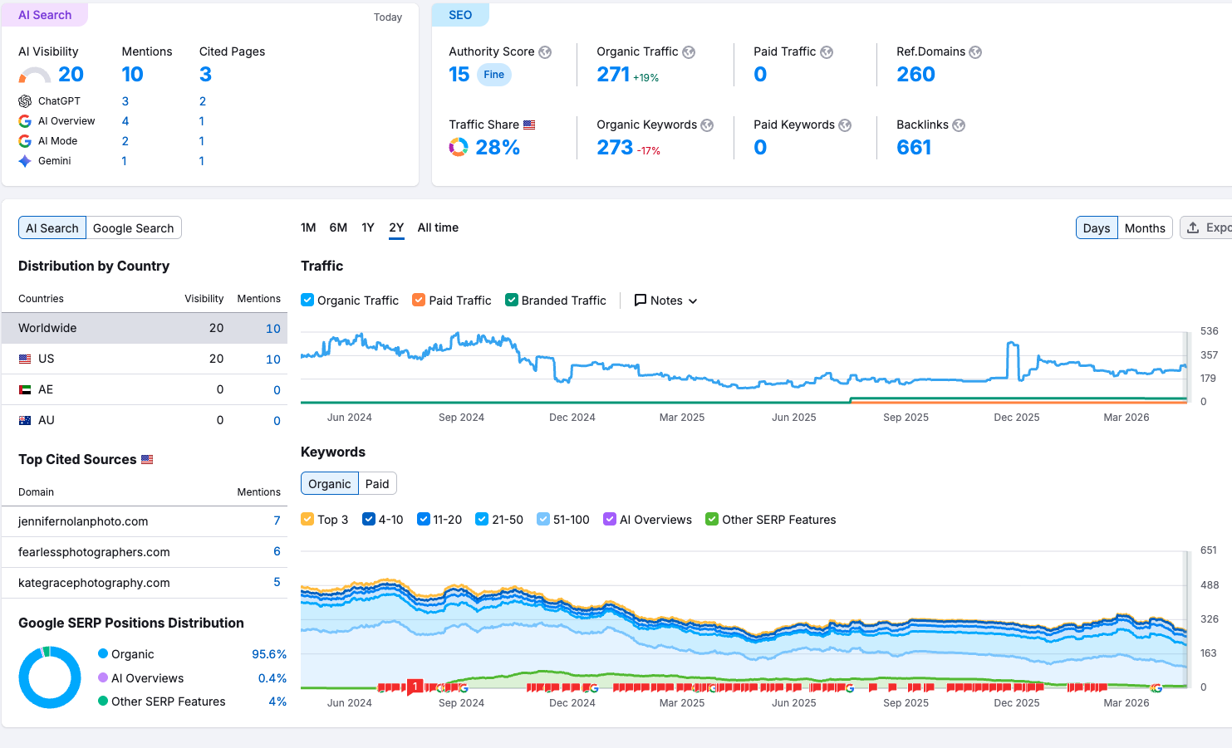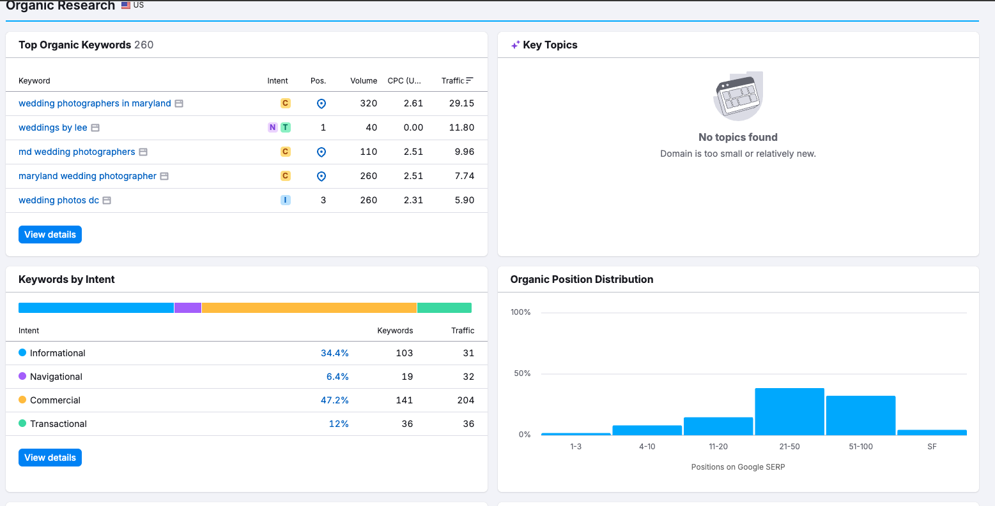

The Domain Overview report shows that Weddings by Lee has an established but still limited organic search presence. The website has an Authority Score of 15, 271 monthly organic visits, 273 organic keywords, and 661 backlinks, with no paid search activity. Its strongest visibility comes from branded and local keywords related to wedding photography in Maryland and DC. However, many keywords are still ranked outside the top positions, which suggests that the site has visibility but is not yet fully capturing available organic traffic. The competitor comparison also shows that several local photography businesses have stronger keyword coverage and search presence. Overall, Weddings by Lee has a good SEO base, but improving keyword rankings, local content, and backlink strength could significantly increase organic lead generation.

KEYWORD RESEARCH

- Using the “Organic Research” tool (navigate to SEO > Organic Ranking > Positions) perform keyword analysis. What are the top 10 keywords that bring most of the traffic to the site? (HINT: Sort by the “Traffic” column to identify the highest-traffic keywords)

- Wedding photographers in Maryland
- Weddings by lee
- Md wedding photographers
- DC wedding photographer
- Maryland wedding photographer
- Wedding photos DC
- Wedding photographers MD
- Lee photography
- DC wedding photographers
- Wedding photographer in Maryland
Comment on the extent to which these overlap with the key phrases you identified in step 1? What gaps do you see?
There is a very general overlap with the terms “wedding photographers/photography” and search of the Maryland/DC area. The gaps lie more so in the more specific attributes that target specific dates with availability, the quality of the photographer (best), reviews, and affordability. These keywords, listed in step 1, allow for a much narrower set of search results, whereas the keyword analysis has a very broad set of keywords.

- Exploring keyword opportunities. In the “Organic Ranking > Positions” report, use the Position filter between 4 and 10. Identify one keyword where two or more of your direct competitors (i.e., businesses offering similar services to the same target market) are positioned above you. Explore this keyword noting URLs of the competitors who ranked above you on the corresponding keyword.
(Hint: Click on Open SERP icon to inspects)
<keyword> washington dc wedding photos
competitor web site 1
https://justinkunimoto.com/
competitor web site 2
https://www.kategracephotography.com/

Comment how this list match to the one you created in Step 2:
The keyword optimization feature creates a strong opportunity for improving content and optimization to increase website traffic. Weddingsbylee.com is currently ranked 9th for the selected keyword, although none of the competitors are listed in Step 2. The nature of the D.C. market for wedding photographers is relatively high and competitive, which demonstrates why various keywords and search inputs can produce significantly different results..

- Navigate to “Organic Ranking > Competitors” and enter your client’s domain. Inspect the list of domains identified as organic search competitors to your client.

- kategracephotography.com
- jennifernolanphoto.com
- mantasphoto.com
- alicetranphotography.com
- justinkunimoto.com
- stefanaphoto.com
- katielewis.co
- adammason.com
- rodneybailey.com

Comment if you see any direct competitors in this list:
“These domains represent direct competitors in the wedding photography market, particularly within the DC and surrounding areas. Many of these businesses offer similar services, target the same customer segment, and rank for overlapping keywords. Several competitors, such as justinkunimoto.com, stefanaphoto.com, and adammason.com, show significantly higher keyword coverage and traffic levels, indicating stronger SEO performance. This suggests that Weddings by Lee is competing against well-established photographers with more optimized content and greater online visibility. Overall, the list confirms a highly competitive local SEO landscape and highlights the need to improve keyword targeting and search presence.”

- Navigate to the “SEO > Keyword Gap” tool. Enter your client’s domain and one competitor’s domain you identified in Step 7.

Comment on the statistics of unique and overlapping keywords for the two sites. (Hint: Review the keyword overlap visualization at the top of the report.)

“The competitor ranks for a larger number of keywords, including several that Weddings by Lee does not currently target. There is a moderate overlap, but the competitor has stronger visibility across high-volume and high-intent search terms.”

Explore the keyword table below by switching between filter tabs: “Shared,” “Missing,” “Weak,” “Strong,” “Untapped,” and “Unique.”
List 3 keywords unique to your competitor that you may want to get ranked on. Consider using “KD” for keyword difficulty.

- quality wedding photographer
- Meridian House DC
- Washington DC wedding photographer

Identify one shared keyword where your competitor has a more prominent placement in search results that you want to target for your SEO efforts.

Hint: use (a) your current competitive standing (i.e., there are not too many direct competitors positioned above you), (b) keyword’s relevance to your business (i.e., it is likely to be used by prospects), and (c) keyword popularity (i.e., with the respect to search volume).

<your target keyword> best wedding photographer dc
Explain your choice: “This keyword is highly relevant to potential clients actively searching for services and has strong search volume. While competition is high, improving ranking for this keyword would significantly increase visibility and lead generation.”

BACKLINK ANALYSIS

- Navigate to “Backlink Analytics” (under SEO > Backlinks), enter your client’s domain, and open the “Backlinks” tab. What are your top 3 “DoFollow” backlinks in terms of Authority Score (AS)? (HINT: use Filter option to select DoFollow backlinks only)

Top Backlinks:
- www.ajdjservices.com/（AJDJ Entertainment Services）
- washingtonian.com/2020/02/14/photos-from-washingtonian-weddings-unveiled-2020/（Washingtonian）
- www.zola.com/wedding-vendors/wedding-photographers/weddings-by-lee-photography（Zola)

Do you think these sites bring qualified leads to your client?

These sites likely bring qualified leads, but their value differs. Zola is the most likely to generate qualified leads because users on the platform are actively searching for wedding vendors. Washingtonian may also bring qualified leads because it has strong local relevance and visibility in the DC market. AJDJ Entertainment Services is somewhat relevant to the wedding industry, but it is less targeted to people specifically looking for a wedding photographer. Overall, Zola and Washingtonian are stronger lead sources, while AJDJ is likely more useful for referral credibility than direct lead generation.

- Go beyond the top 3. Find one site that, in your opinion, is a good source of referral traffic to your client.
Explain

MyWed is a good source of referral traffic because it is a photographer directory platform that attracts users who are actively browsing photographer profiles and portfolios. This makes the traffic more relevant than general websites, and it may help Weddings by Lee reach potential clients who are comparing photographers during their search process.

- In “Backlink Analytics,” switch to the “Indexed Pages” tab. What are the top 3 pages on your client’s website that get the most inbound links?
  - https://weddingsbylee.com/
  - https://weddingsbylee.com/21-best-honeymoon-destinations-for-2021/
  - https://weddingsbylee.com/average-cost-of-a-wedding-photographer/

Try to explain the popularity of these pages:
The homepage receives the most inbound links because it is the main branded destination for the business and is the default page that many directories and mentions link to. The “21 Best Honeymoon Destinations for 2021” article likely attracts links because it is broader lifestyle content with informational value beyond the photography niche. The “Average Cost of a Wedding Photographer” page is likely popular because it targets a high-intent question that many engaged couples search when planning their wedding budget.

- In “SEO > Backlink Gap,” enter the domain for your direct competitor: kategracephotography.com Explore the list of the sites giving a backlink to this site (look at DoFollow links only). Identify 3 sites on this list that would be a good target for your client to get an inbound link from. (Hint: consider Traffic, Authority Score (AS), and Relevance as criteria).

Backlink target site 1. Why is this a good site to get a link from?
pinterest.com - Pinterest has very high authority and strong organic traffic, and it is highly relevant for visual discovery and wedding inspiration.

Backlink target site 2. Why is this a good site to get a link from?
redfin.com - Redfin has strong authority and traffic, and it may provide valuable exposure if the backlink appears in locally relevant lifestyle or venue-related content.

Backlink target site 3. Why is this a good site to get a link from?
peerspace.com - Peerspace is relevant because it is connected to venues, events, and creative spaces, which makes it useful for reaching people planning weddings or related events.

- Select one site identified in step 13 and explore the content of the page(s) giving an inbound link to your competitor. Briefly describe your strategy of acquiring an inbound link for your client (i.e., how could you get a backlink from this site?).

The page to get a backlink from:
pinterest.com

Describe your link acquisition strategy with this referrer:
To earn a backlink from Pinterest, Weddings by Lee should create a business account and publish visually appealing pins that link back to the website. The client could post real wedding photos, venue-specific shoots, portfolio highlights, and blog content related to wedding planning in DC and Maryland. Each pin should include keyword-rich descriptions and a direct link to a relevant landing page, such as the homepage, portfolio pages, or blog posts. This would increase the chance of generating referral traffic and backlinks from users actively searching for wedding inspiration and photographers.

Submit the report on ELMS

